**Neoden4 Manual**



## **Intro**

This manual is provided by e-radionica.com. e-radionica.com is electronics manufacturer from Croatia, Europe. We design and manufacture Arduino compatible

boards named Croduino, as well as many different breakout, sensor and actuator boards. We do also write about hardware, electronics and different projects which you can read on our blog.We do also write about hardware, electronics and different projects which you can read on our blog. You can find more info about our offer on our webpage:https://e-radionica.com/en/?___from_store=hr

While we were using the machine for our own or external manufactures, we faced a lot of problems and looked for their solutions. Manual itself is made to keep all necessary information regarding use of the Neoden4 pick and place machine. It is roughly divided in 4 chapters to keep its simplicity, but also consist solutions to possible problems/issues users can face while operating the machine. First chapter will describe how feeders (devices or trays components are loaded from) should be set. Second chapter is all about how to create a pick and place file on your machine. (manufacturing file) This chapter will also include the ways of exporting .csv files out of Cadsoft Eagle or Altium. Third chapter will include possible problems and their solution which users can encounter while using the machine. In the final, fourth chapter, there will be some useful tips on how to keep your machine in good shape to avoid malfunctions.

Instead of browsing many forum pages, you can use this manual to set up, manufacture and maintain your machine properly.

## **Setup**

After you’re done with unboxing and assembling the machine (placing and fixing on its stand), you are ready to set feeders and peelers that came with the machine or have been bought separately.

Sides of Neoden4 have 48 connection ports (both for feeders and peelers). After connecting feeder and peeler to the same port number, please go to: **System setup** > **Feeder configuration** > **Modify Feed ID** (button on the right side of the screen)

Once feeder and peeler are connected, feed box is automatically assigned to #50.  
By clicking on Modify Feed ID, a pop-up window opens and allows to change default ID number of selected feeder to desired one. (for example, if connected feeder and peeler cables are inside ports #1, select correspondent feed-box in the “Modify Feed-Box ID” window)

After that, click on “click to test” to check if feeder set (feeder and peeler) is working properly. (both feeder and peeler should make a step)

**IMPORTANT!** Feeders should be connected and assigned one by one! Physically connect both cables (from feed-box and peel-box) and after that, inside the software, assign the corresponding port. Otherwise, an ID conflict will occur. Solution to the conflict is under 3.1.

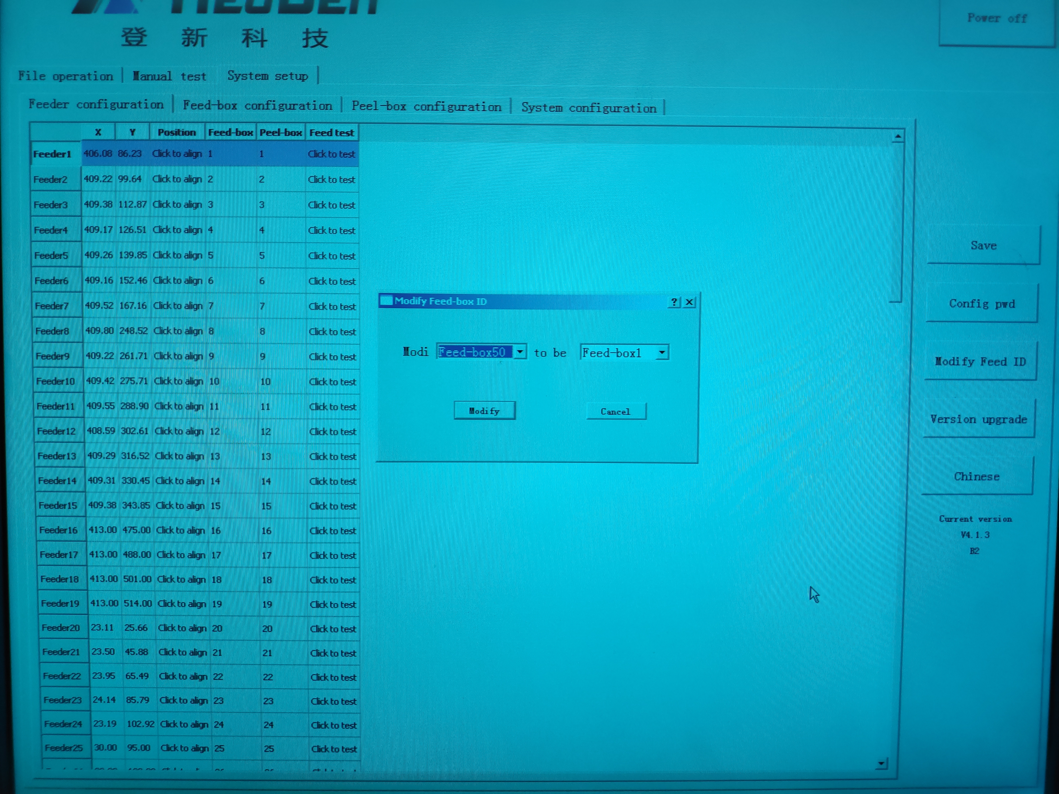

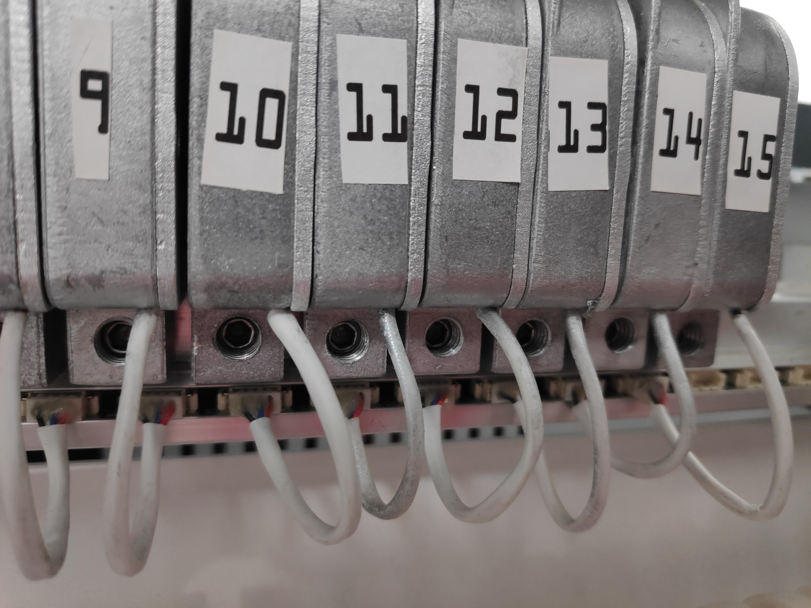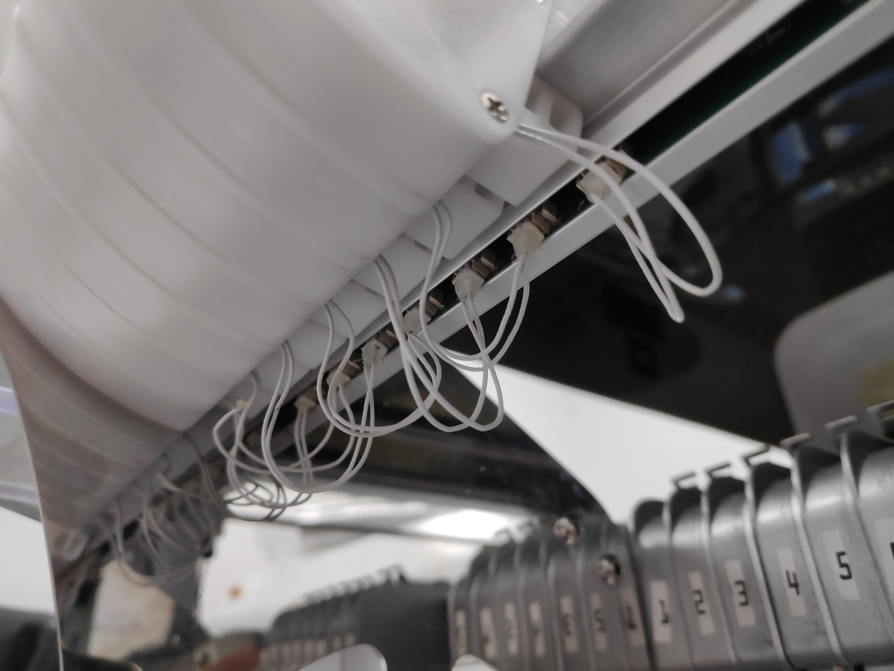

From time to time, there are projects that require a lot of different components. Regarding their sizes and variety, maybe there won’t be enough feeders on Neoden4. For example, large components like ESP8266 usually comes on a large reel tape which cannot be placed in any size of Neoden4 feeders. (Neoden4 feeder sizes: 8mm, 12mm, 16mm, 24mm)

Therefore, there is a special tray needed for that components. For ESP8266 WiFi microcontroller we made 4x8 tray using our 3D printer. From time to time, component distributors can send components in appropriate holders which can be used as trays in your production.

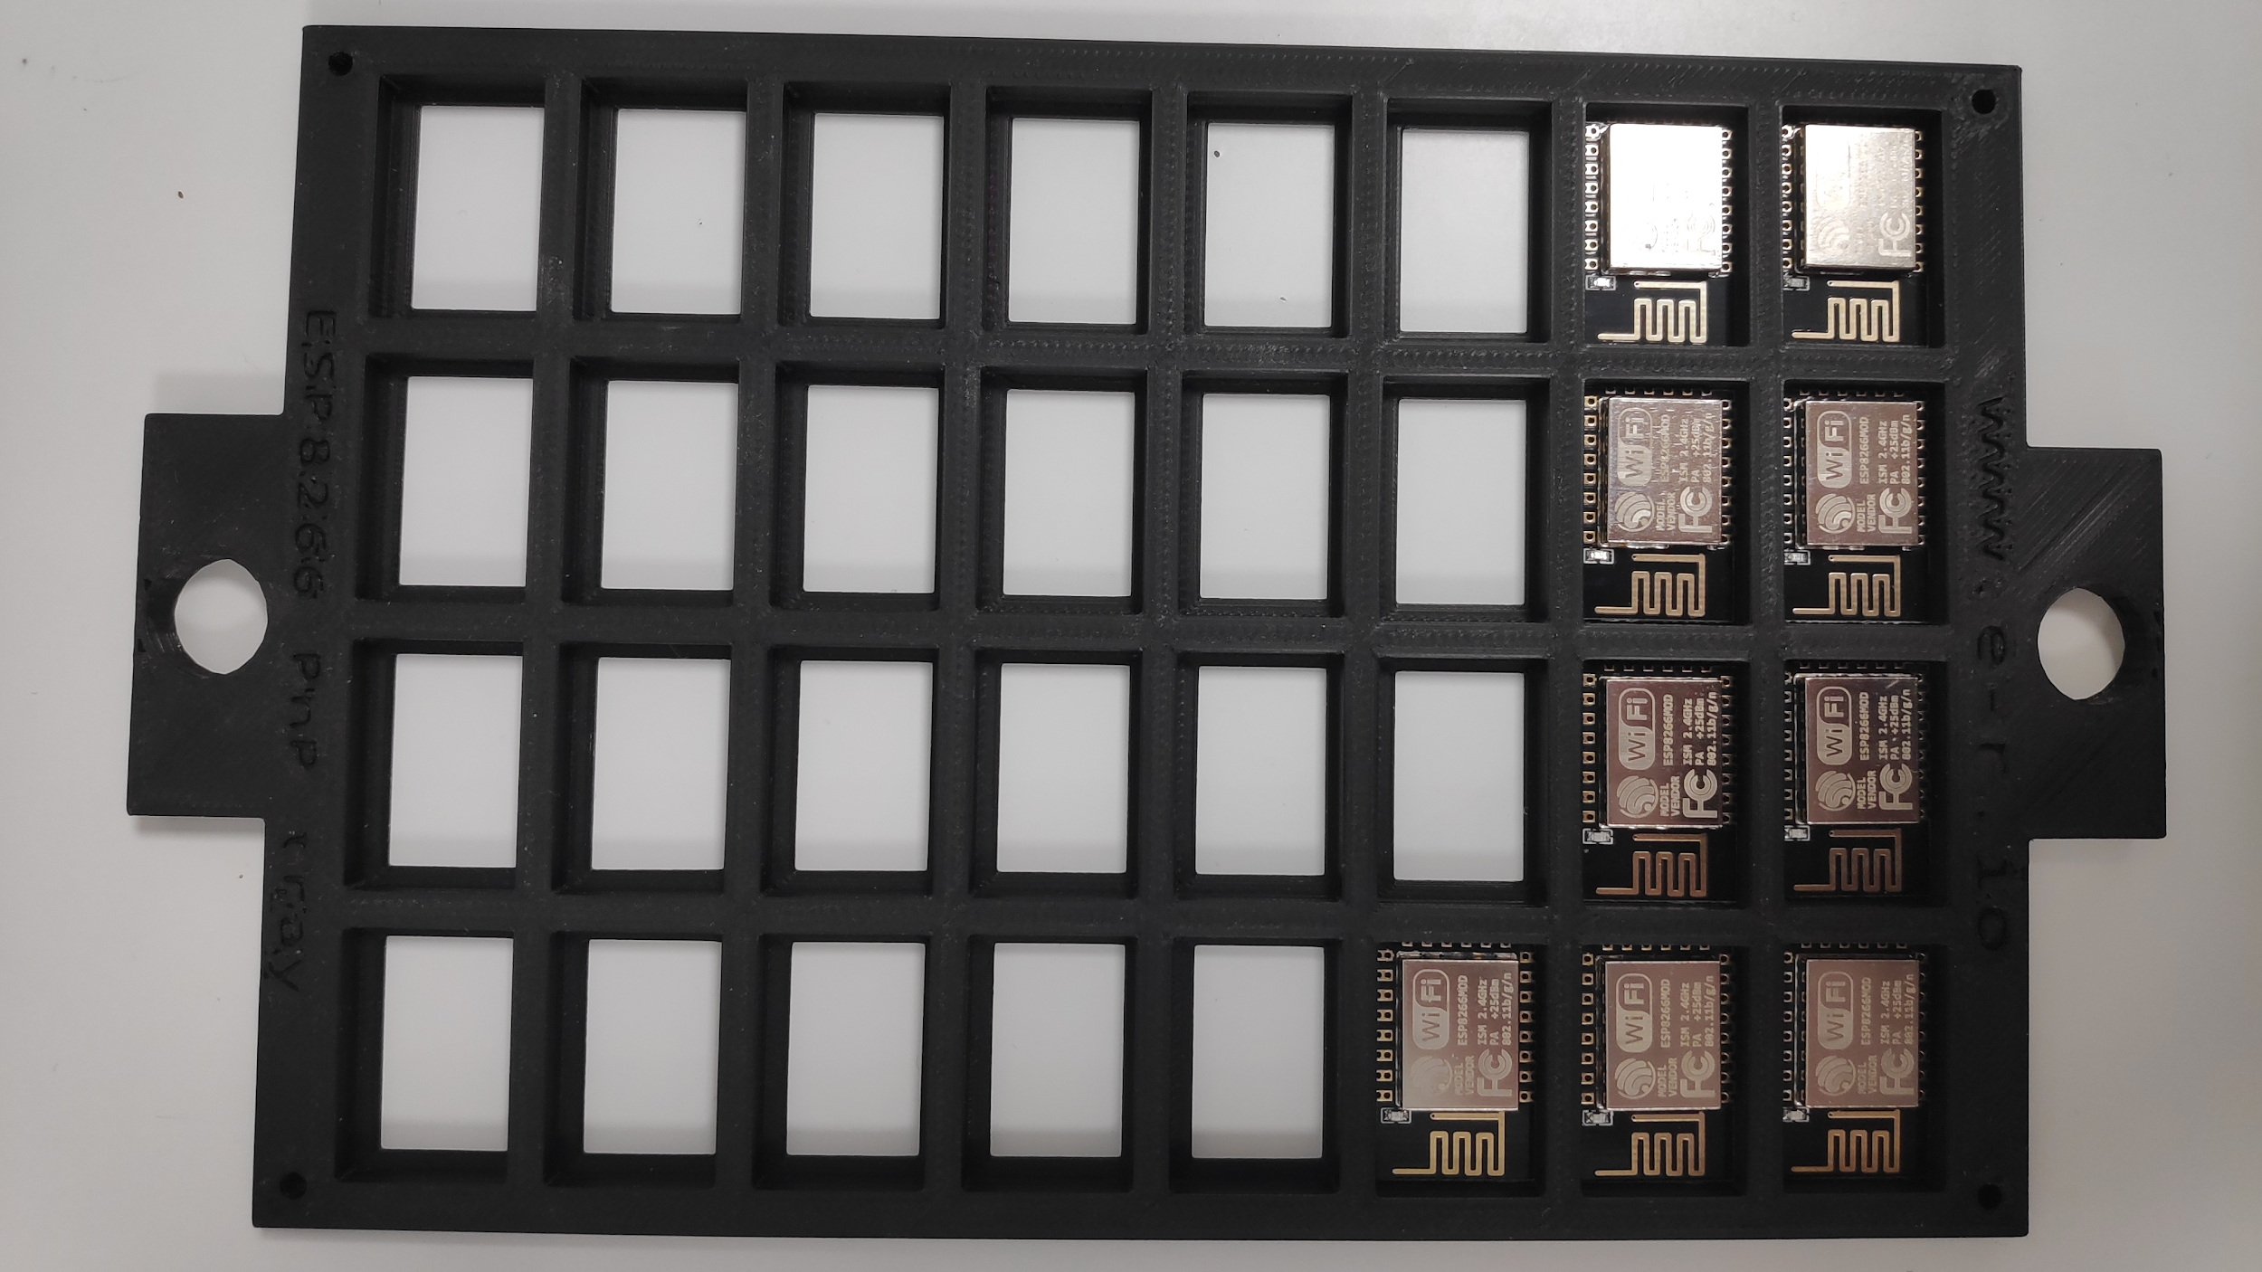

When it comes to set up a component tray like it is used in the picture above, it is done inside manufacturing file, under “Feeder settings” tab (far right on the screen “Special feeder”). So basically, tray setups are made during production inside files which is described in chapter 2. On the right side on the page there is a section “Tray feeder information”. Rows and columns parameters will define dimensions of our tray (quantity of components inside the tray). With X and Y coordinates of Right Top component the last components of the tray is defined. Use Align to set coordinates of the last component in the tray.  
If tray isn’t full (components are placed somewhere on the tray -> keep in mind they still need to be placed in rows and columns, near each other), select the picking start point by using Start X and Start Y parameters. Default value is X=1, Y=1 and machine will pick components from left to right, starting at first row / first column of the tray. That’s also the spot coordinates are manually set for by using Align function inside “Feeder basic information” section while setting a new “Special feeder”. More details can be found in chapter 2.

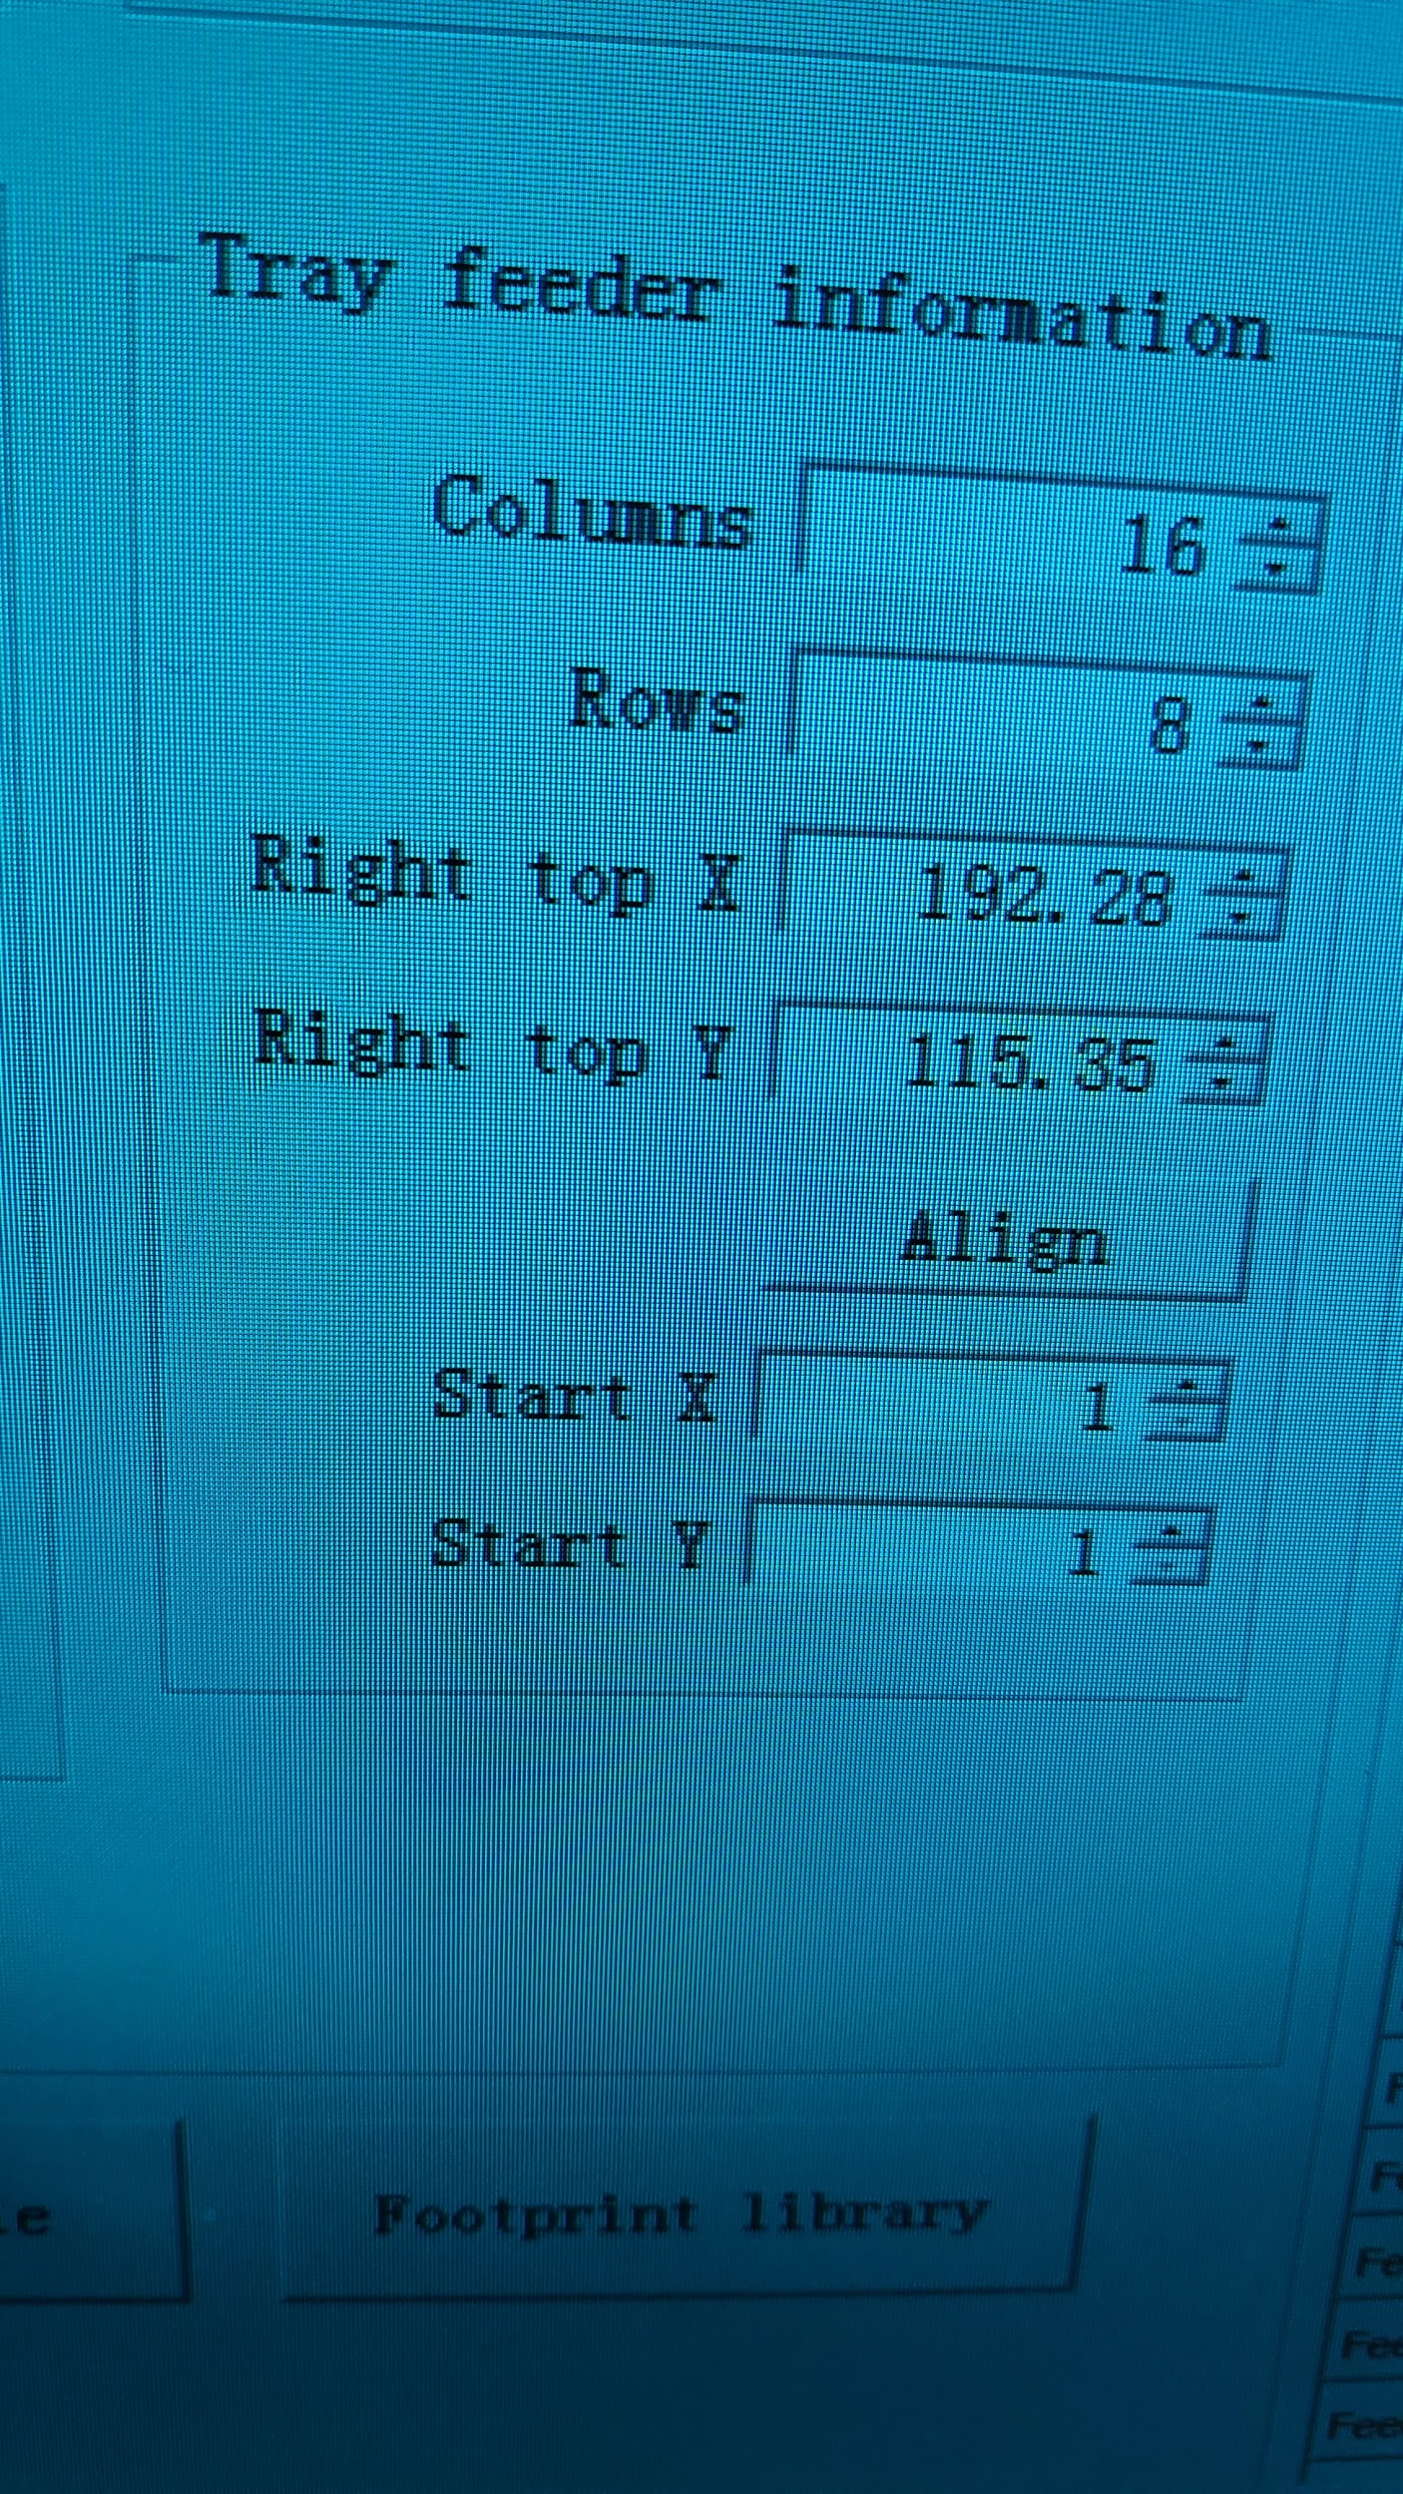

Sometimes components can be packed inside sticks. Those can also be used as “Special feeder” trays, but there is a special place for them on the machine. Check the picture below. Picture shows a custom stick holders and the stick itself which we opened in one component’s length (maybe a few millimeters more). In order to use a stick feeder, vibration must be applied during the production. (There is a check-box in the window after “Mount” button is pressed.) More details about stick tray in chapter 2.

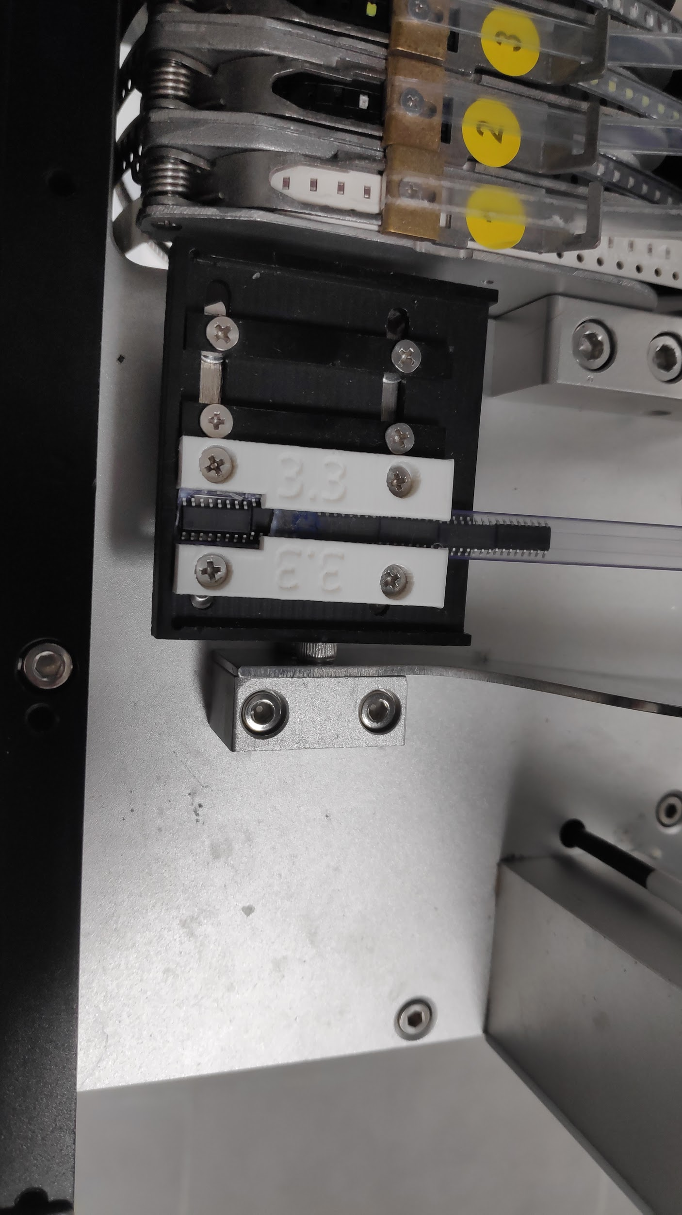

## **Manufacturing**

After Neoden4 is set and after some trays are placed, it is time to create a manufacturing / operating file. Button “New” inside “File operation” tab will open a window to set a name for new file. After the file is created, it is time to edit and define what it will do. By pressing “Edit” button, a window will open. This window consists of two tabs in which first “PCB information”, as name says, defines parameters of PCB and second “Feeder settings” enables to assign components to selected feeders.

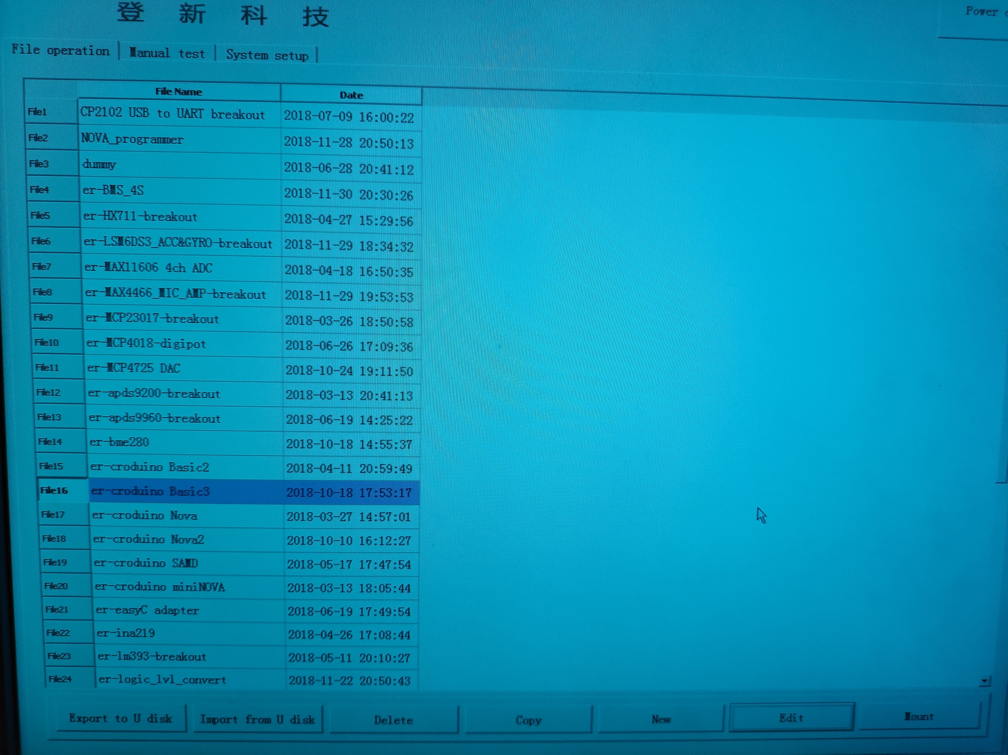

First step under “PCB information” tab is to declare whether PCB will be fixed on a metal plate(large flat metal plate used for both PCBs and IC trays) or will be fed with rails (PCB feed settings). If option “Tray fixed” is chosen, “Rail once” will disappear. Only requirement is to securely place PCB using magnets which came with the machine. However, if it is intended for machine to feed the PCB using rails, first thing to set is position (coordinates) in which placement head will wait for PCB to feed. By using buttons “Forward” and “Backward”, PCB will move inside the rail. Button “Align” is used to set coordinates of top edge of the board. There is no need to waste too much time here. Camera’s crosshair will help at this point. Save the coordinates.

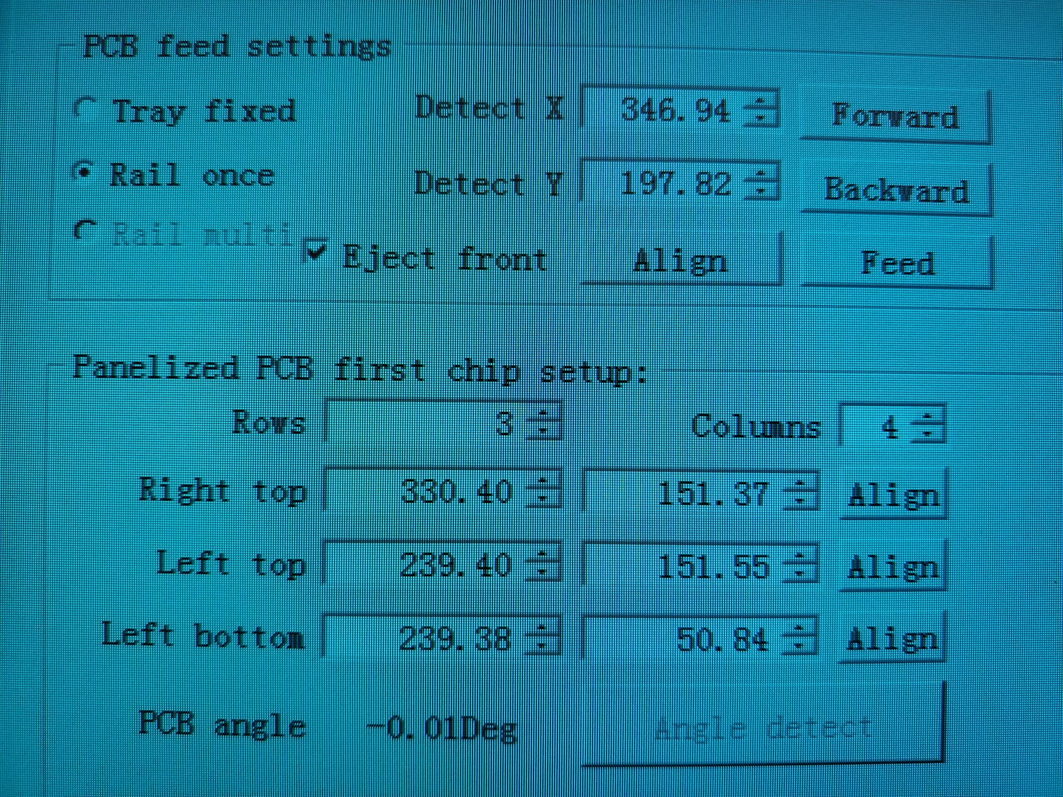

In the second step (Panelized PCB first chip setup), it is decided whether PCB is panelized or it is a single board, also if it is panelized, how big panel is (how many rows and columns it has). Also it is defined what the first component of the board will be. Process of whole production depends on this section because coordinates of other components are calculated in regards to first component. First component by itself is set (chosen) even before, inside Eagle software.

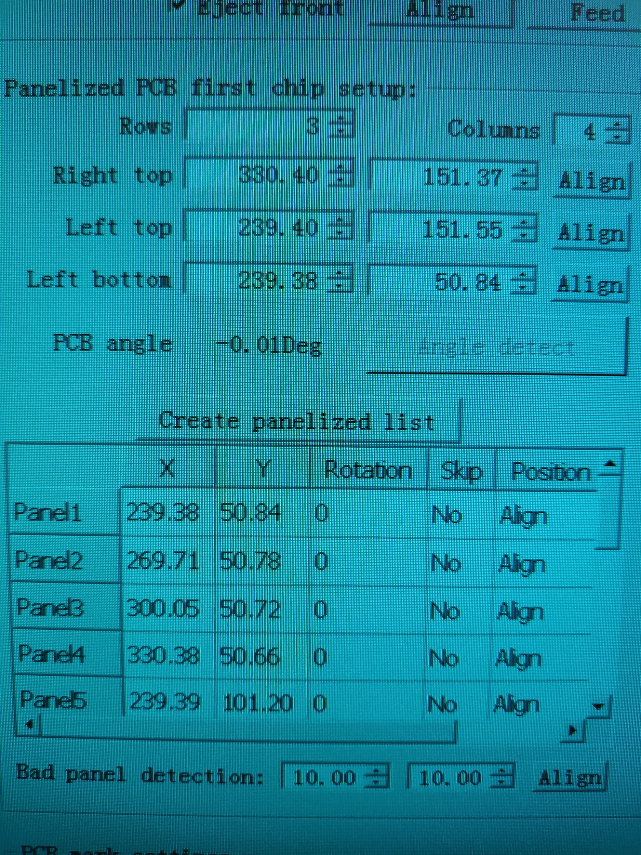

First thing to do is to check which component is the first one on list of components. In e-radionica we generate component (.csv) files by using a script. One of Eagle’s tools is “Run ULP”. It can be located inside Board Layout of a project (upper toolbar). Tool itself will open a browsing window and desired script must be located / opened (We will provide the same script we are using). Generated .csv file needs to be saved and loaded from Neoden4 in the future. Saving it on a flash drive is the only option because Neoden4 uses USB ports only. At the moment there is no need to set “Machine parameters”, just press “Generate”. At this point, list of components is used only to check which component is the first one (whether it is, for example, R3 resistor on board, or C1 capacitor). Microsoft Excel (or notepad) can be used to open .csv files. First component will always be at the top of the list. After name of the first component is determined inside .csv file, using Neoden4’s “Align” option, locate first component’s coordinates on PCB and write them down. Next step is to add those written coordinates to the same script. This time, those will be typed inside “Machine parameters” after we run the script again. New .csv file can be saved to the same location, it should overwrite the previous one. This is really important part of the manufacturing process because, as we already said, using first component’s coordinates, script will calculate coordinates of other components in the .csv file.

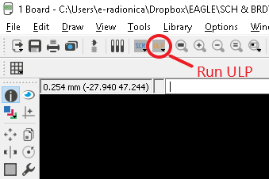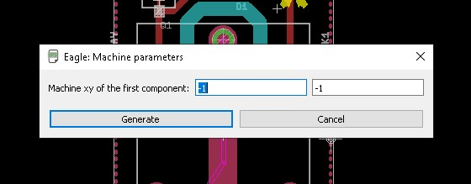

It is time to determine how many rows and columns PCB panel has if there is one in the first place (components can be placed on single boards as well -> rows=1, columns=1). Like it was done and explained earlier, rows and columns are set in the same way. Inside fields below, coordinates of first component are set. Note: If is it meant to use the machine for placing components on only 1 board (not panelized), there will be only one field available to set coordinates of the first component. In other case, when panelized board is used, coordinates of the first component will be typed in. Left field stands for x-axis and right field stands for y-axis (same goes when adding coordinates to .ulp script inside Eagle).

Coordinates of “Left top” and “Right top” are set manually.

Next step is to create a panelized list.

Software will generate coordinates of each first component on a panel. Since the panel is, by default, made of the same boards, each board on the panel will share the first component, only coordinates will change.

**

Next section is “PCB mark settings”. Those marks are usually known as fiducials. Fiducial is an ordinary pad placed on a board (while designing a board) so that pick and place machines (just like Neoden4) can calculate alignment of components. (This has nothing to do with component rotation). When rails are used to feed a single PCB or PCB panel, each time board will approach camera at different angle. Fiducials are used there to be recognized and according to their positions, machine will mitigate missalignment of each component on the board. “Single” should be checked if there is intention to place components on a single or panelized PCB. After that, by clicking on “New” button, fiducials are added. Their positions should be aligned by camera. Inside camera view, there are options: switching between light sources (inner lamp for holes, outer lamp for pads), movements methods (“overall workbench” for larger movements across the board), alignment methods (camera as default) and 2 buttons (“Mark Align” which is actual computer vision for getting fiducial coordinates and “Save” to save found coordinates). Regarding light source, “Inner” is used when fiducials are some sort of holes in the PCB and “Outer” is used when fiducials are actual PCB marks (pads).

Also, by addressing “Min” and “Max” values, Neoden4 will only look for elements inside that dimensional range. Dimension values are in millimeters. For example, if Min=1, Max=1.5, Neoden4 will look for elements that are larger than 1 mm and smaller than 1.5 mm. By setting those parameters, user can deny machine from recognizing unwanted elements as fiducials.

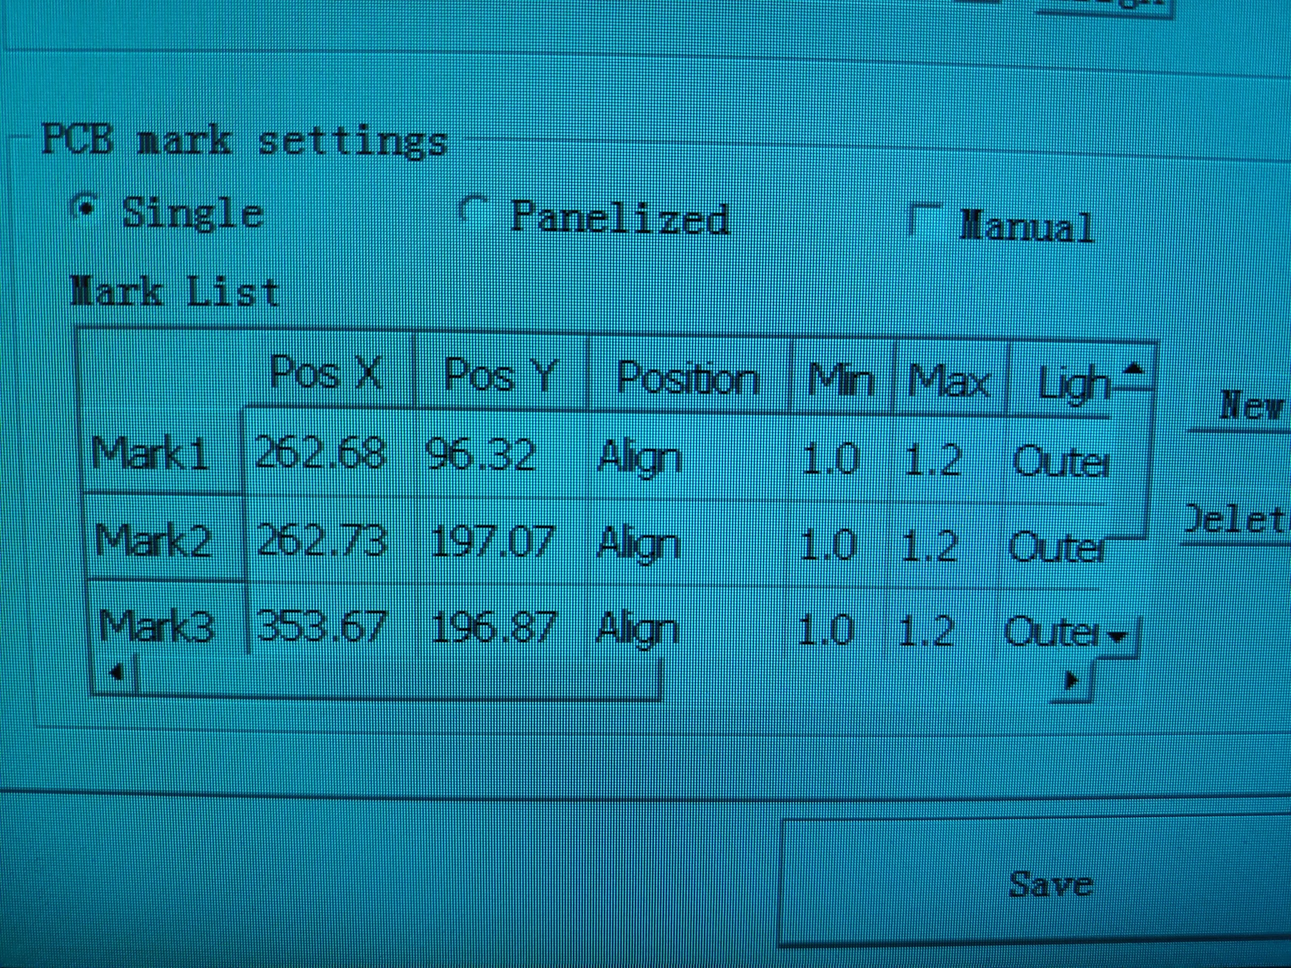

Next step under “PCB information” tab is to import previously created .csv file to the operating file. Alternative is to check “Manual” in the checkbox, add items to list by clicking button “New” and set their values manually. Using “File import (top layer)”, a browsing window will pop up (previously inserted USB flash drive is opened). “Delete” option is obviously for deleting items from the list manually, “Up” and “Down” button are used to move through the list. After desired file is opened, it is time to check the component rotation, but that step will be described later on.   
  
“Feeder settings” tab will be used to assign items from the chip list to actual feeders on the Neoden4. Here, it is time to determine the position on component trays / tapes on the machine. Whether there is a component tray or reel tape, it must be assigned to some feeder ID on the machine. On the left and right side of the screen there are multiple feeder IDs (left, right and special feeders). Talking about left and right feeders, only one type of component from the chip list can be assigned per one feeder ID. Unlike special feeders, where various components can be placed inside tray (depending on tray design). For example, single tray for multiple different components is used in operating file. Each component will require its special feeder ID. Most likely, a custom component tray is required (3D printed for example, picture below). It is important to keep in mind that there is a fixed number of special feeders as well. Also, if there are few repeating types of components, it is wise to create their slots on the tray near each other (while designing the tray). That way, parameters from “Tray feeder information” section can be set which will enable to set three actual components (because they are of the same type) from one special feeder ID. It is some sort of “Smaller tray in a tray” solution.

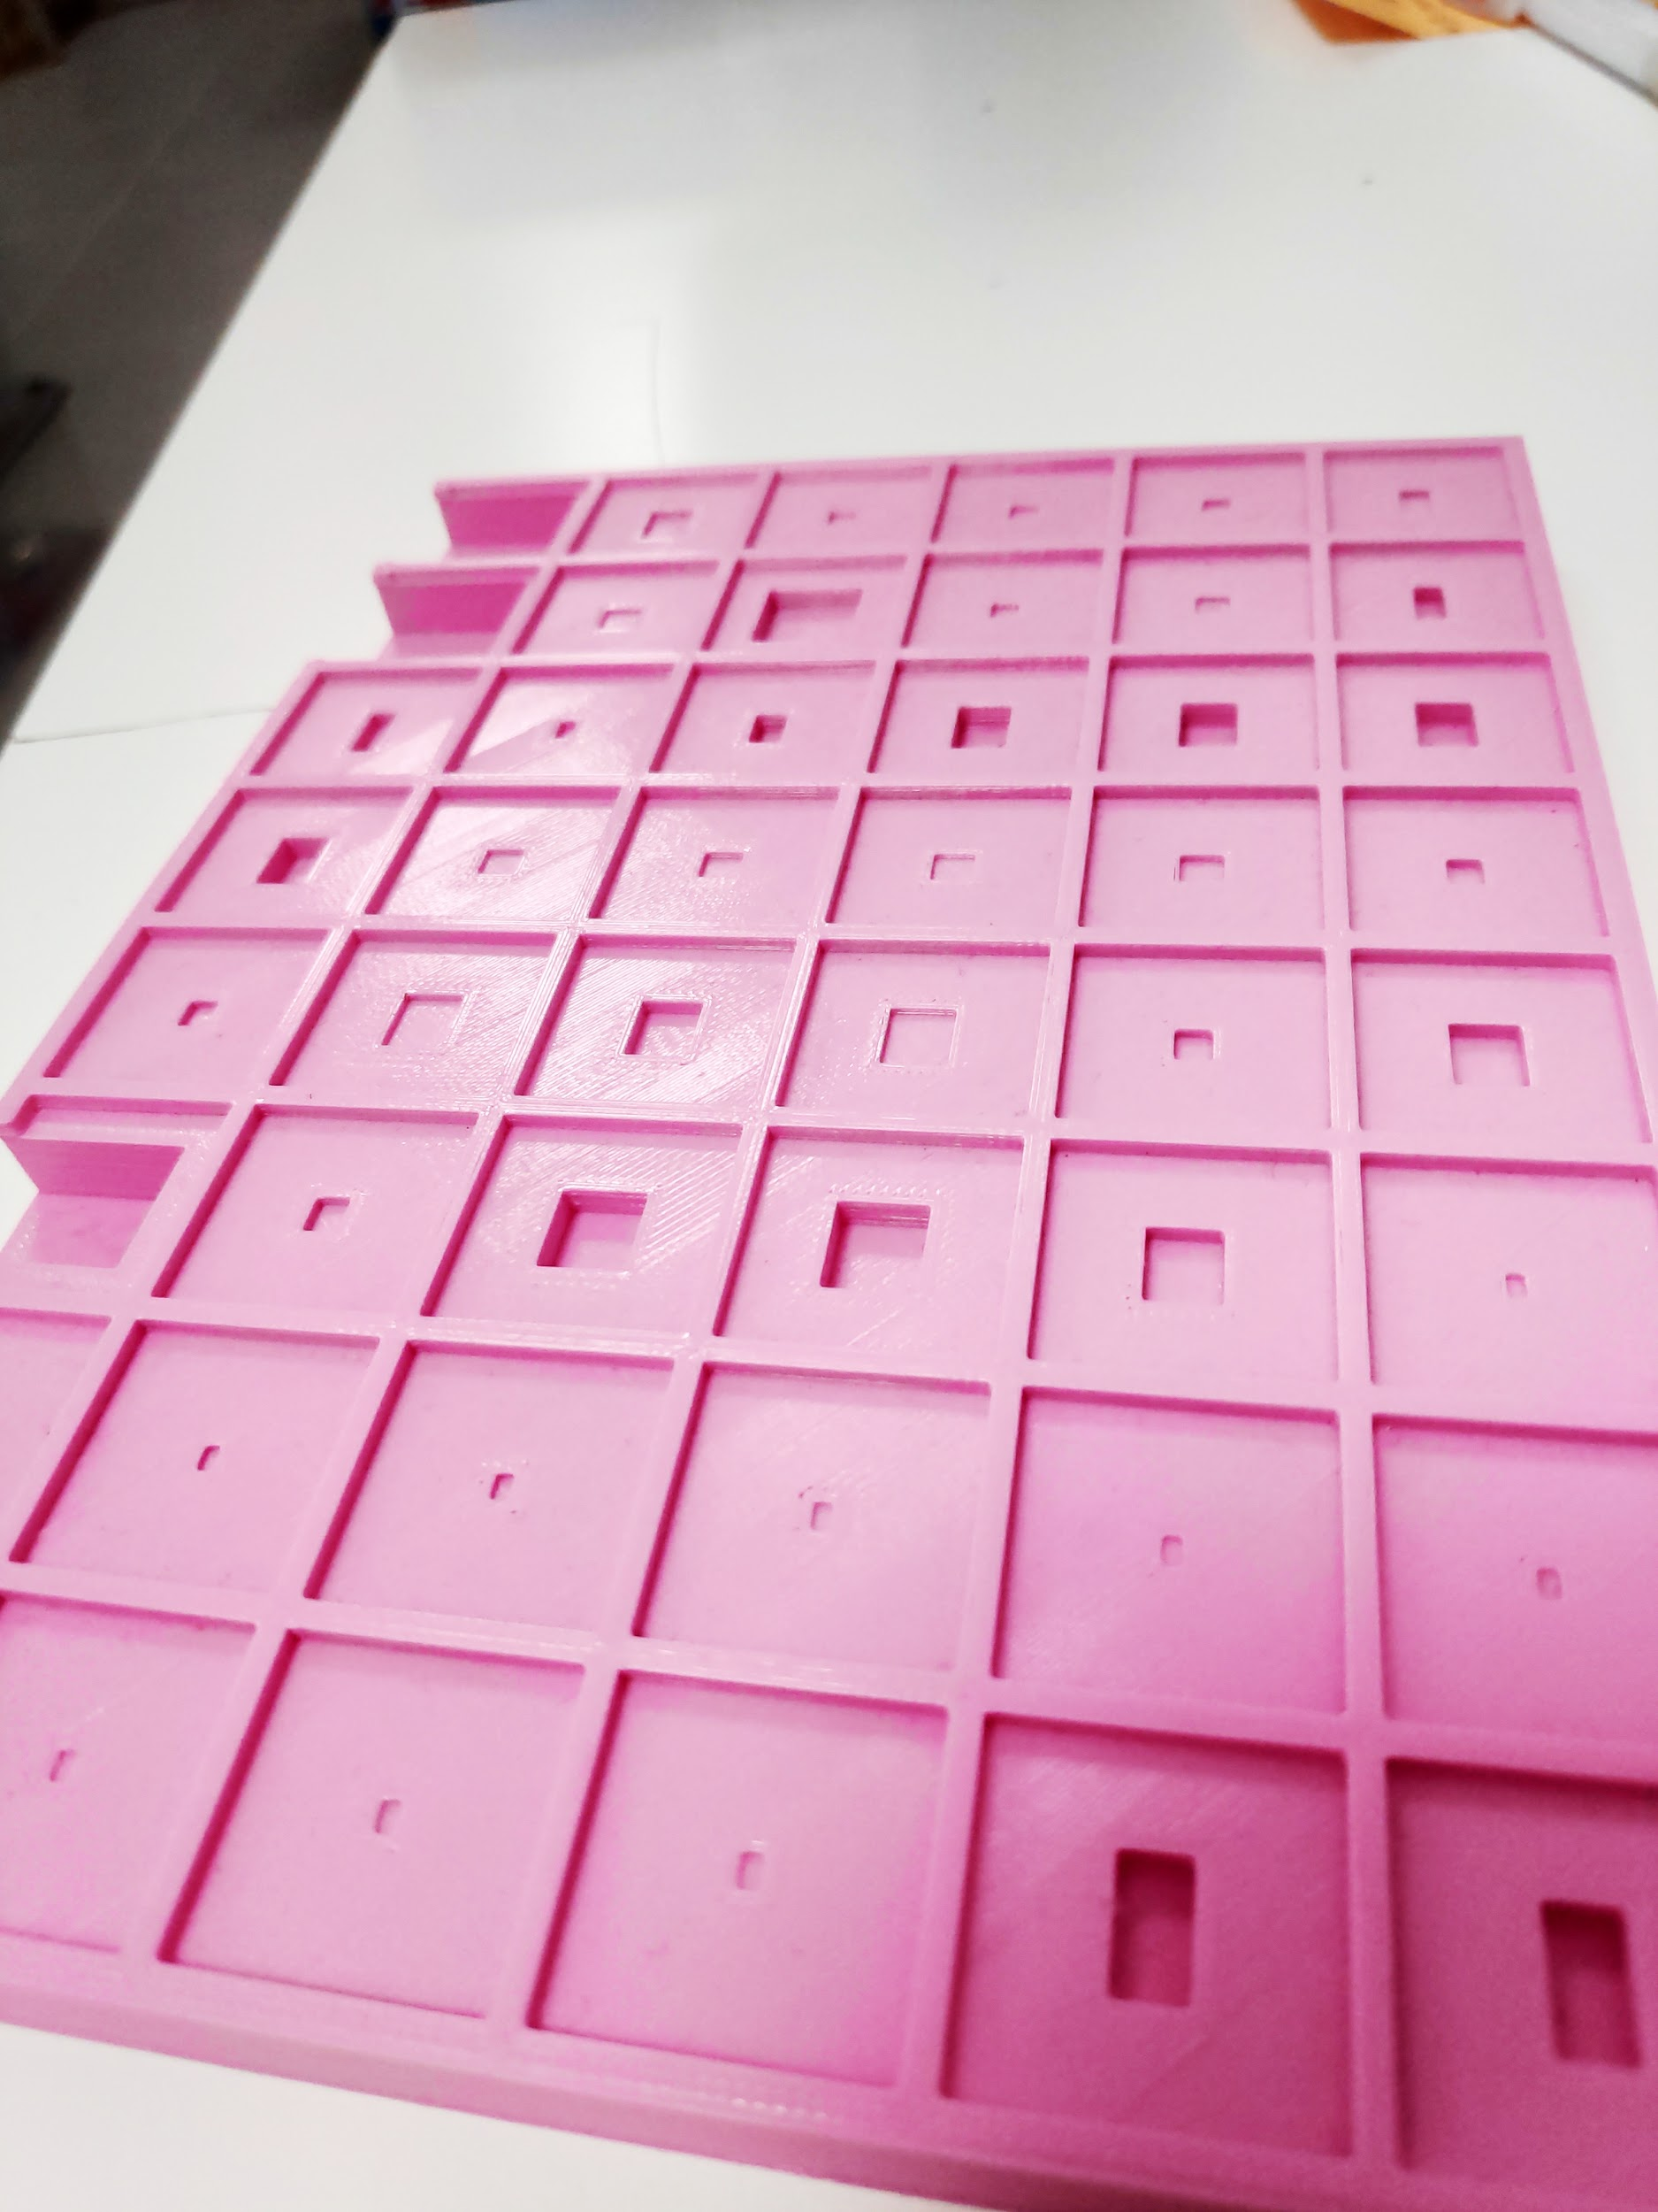

Inside “Feeder settings tab” there are few important sections for each feeder ID which will determine how Neoden4 will handle component picking and calculations. First section “Nozzle information” enables nozzle selection and their testing. Nozzles vary in diameter depending on the size of components that are picked up. In addition, we suggest considering what production requirements users can meet and according to that, choose which nozzles to buy. It is recommended to equip Neoden4 with various types of nozzles so users can expand their production capabilities. Second section “Feeder basic information”. By using “Align” function, picking point of component is selected. We suggest using camera vision for point selection (“Mark Align”). Values of “Pick height”, “Pick delay”, “Place height” and “Place delay” are adjusted inside each operating file, depending on the components being picked up. “Pick angle” is very important parameter because it affects component rotation in a specific way (like already said, component rotation will be explained later on). It has default values for left, right and special feeders which have to be considered while setting component rotation inside chip list (default left feeder=-90, default right feeder=90, default special feeder=0). “Move speed” determines the speed of placement head towards the board after it picks up a component. Under “Footprint”, matching footprint must be selected. If user cannot find a suitable footprints for components, those can be always added manually to current/default footprint library. By clicking on “Footprint library” button, a footprint list will open. User can expand that list by adding wanted footprints. Type in footprint’s name, its dimensions and save the file. All dimensions are usually found inside component’s datasheet. After that, save operating file using button “Save” at bottom left of the screen and reopen the operating file. Navigate towards feeder ID which was edited inside “Feeder settings” tab and under “Footprint”, now, there should be the new one, created few moments before. “Vision alignment” will provide selection between three options (individually, jointly, large component). Individually should be used for larger components, jointly when there are many smaller ones without polarity inside operation file. “Vacuum detection” can also be used to create a checkpoint in which air pressure sensor will notice if there is some air leaking around component (nozzle didn’t pick component good enough). Machine will drop the badly picked component and pick a new one. Inside “Feed-box information” user can set how strong feeder will move the tape, as well as how strong peeler will peel the foil from the same tape. “Feeding rate” is very important parameter which determines how big movement step is. This should be kept in mind. Of course there will be differences in feeding rate between 0402 resistor (0402=size of the package/footprint) or DPAK NMOS (DPAK=package/footprint). “Tray feeder settings “ section was explained earlier and it can set only inside special feeder ID range.

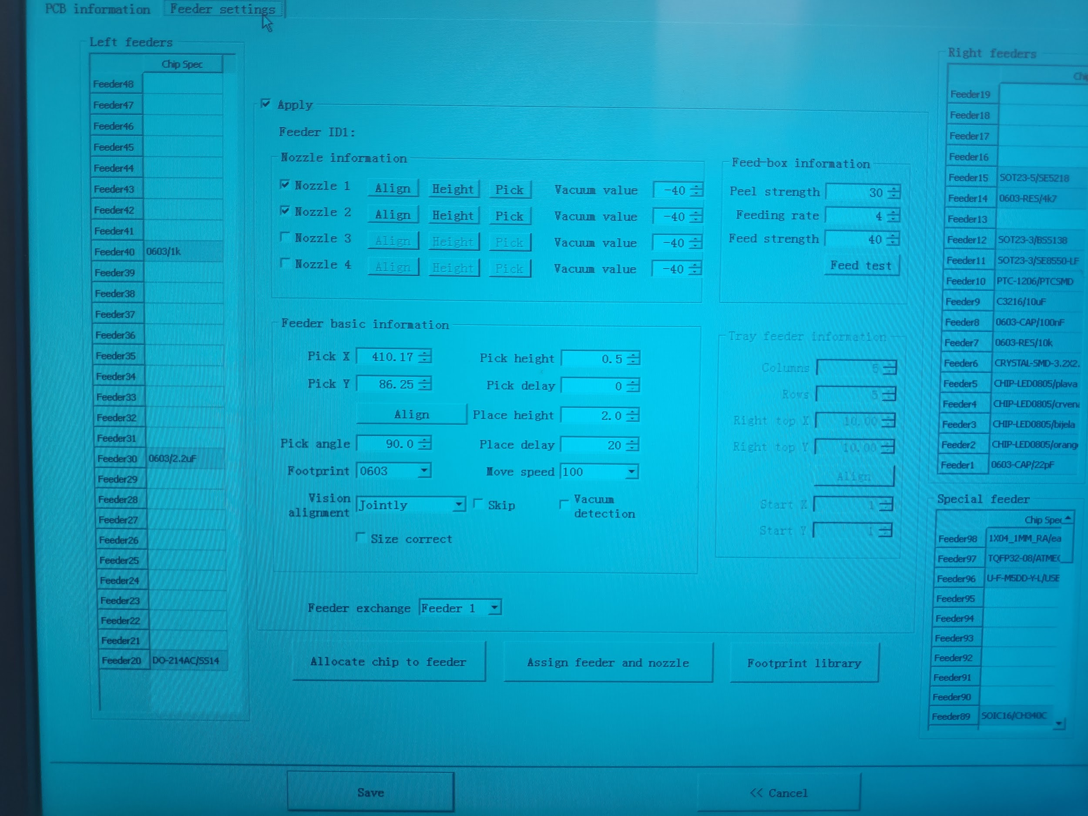

After all sections are set it is time to press the “Assign feeder and nozzle” button.

Now, after feeders and nozzles are assigned it is time to check and fix the rotation of components if it is necessary. Rotation is set inside chip list (Rotation column) under “PCB information” tab. When setting a component rotation, please keep in mind the pick angle (“Feeder settings” tab, “Feeder basic information” section) we previously mentioned. When calculating rotation, Neoden4 does “pick angle” rotation first. After that, it adds rotation value from chip list. For example, if 0603 resistor is being picked up and same resistor is placed at left side of the machine (assigned to one of left feeders). That means its default pick angle is -90 degrees. Neoden4 will rotate the resistor -90 degrees counterclockwise. (“-” for counterclockwise and “+” for clockwise) That’s the first part of the rotation process. After that, it will add rotation of -90 degrees to already rotated resistor (by -90). That’s the second part of the rotation process. Surprisingly, the resistor will be positioned the same way like it was positioned inside the reel tape. It is because in the second part Neoden4, for “-” values goes clockwise and for “+” values counterclockwise, opposite from the first step. This rotation process won’t affect the resistor example, but keep in mind that it will for sure if any chip or LED are being rotated (chip’s first pin, LED’s cathode). When rotating such components, follow above explained steps and there shouldn’t be any issues with component placements. After rotation of all components from the chip list are set/adjusted, save the file and exit the editor.

Since manufacturing file is completed, it is time to start placing components. Select the operating file and press “Mount” button at bottom right of the screen. At the left side of the window there is a number of boards on which components will be placed on (if panel is used). Each board can be skipped. Center of the screen is mainly reserved for chip list and camera images. Neoden4 can start with component placement from any board on the panel, also from any component in the file. For example, user wants to skip first two boards of the panel and first ten components of the board. To do that, it is only required to select from which board and which component machine will start the process. Down below the camera image section, there are four bars which represent the amount of air pressure inside the nozzles. There is also a speed bar which allows user to set the speed of placement head. “Auto-eject” checkbox is used to eject PCB at front side of Neoden4 after component placement is finished. “Vibration” checkbox is used to turn on the vibration for vibration stick type of special feeder trays. At the bottom, there are five buttons which do not need to be explained.

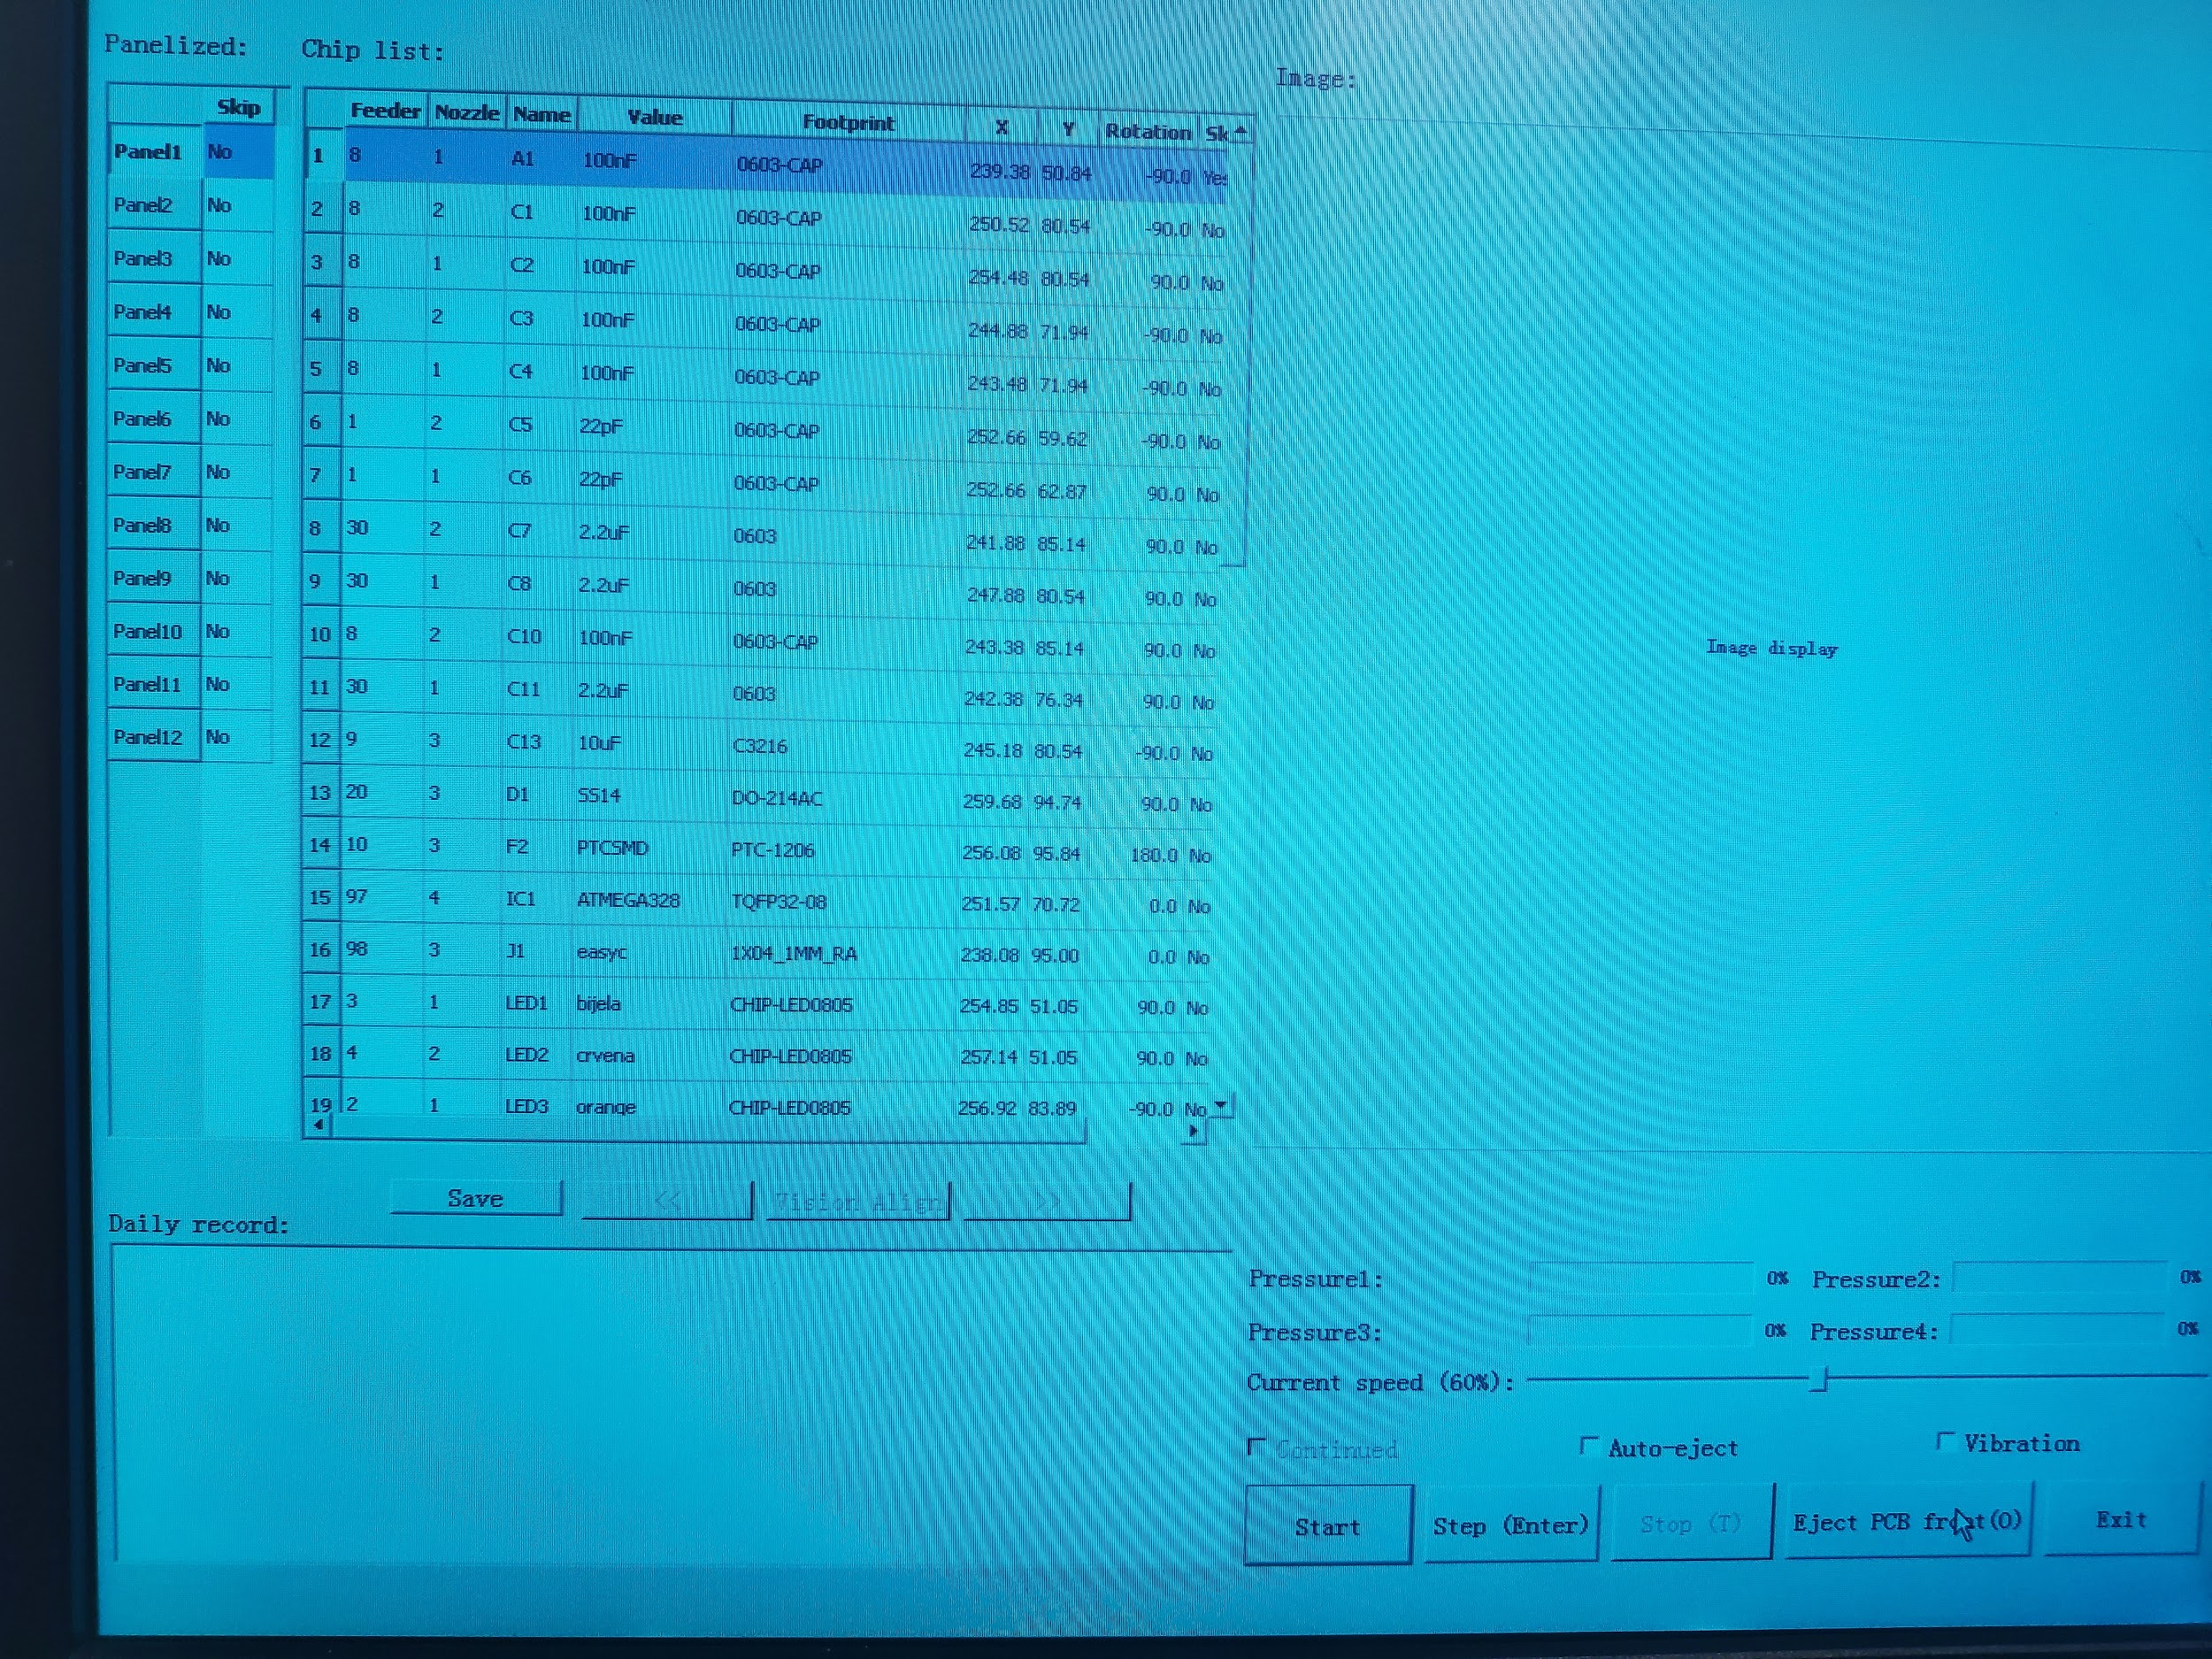

## **Potential problems and solutions**

### 3.1. Feeder ID conflict

In case it happens, find out which feeder isn’t working by using the “click to test” option. (label feed-boxes with their corresponding feeder numbers inside software) If feeder ID reset is required for feeders which aren’t working, all working feeders should be disconnected. After that, inside the Modify Feed-box ID, choose “all feed box” as last option on a list to be “feed-box50”, like shown in the picture below:

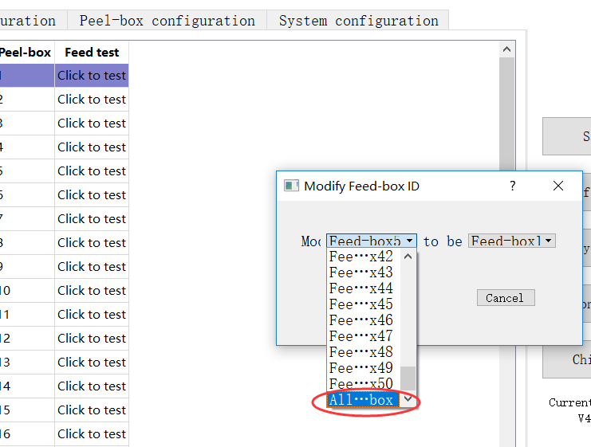

As already explained, this procedure will restore default ID (#50) to all connected feeders at that point. After that, user can assign IDs of those feeders to desired ones by following steps in chapter 1.

### 3.2. Out of Neoden4’s working range

When using rails to feed PCB or panel, it is mandatory to make sure every part of PCB/panel will stay inside working range of the machine, so please make sure PCB is fed far enough to avoid the situation. 0,0 coordinates of Neoden4 are at the bottom left (while looking a the front side of the machine). Consider this information and adjust placement head’s waiting point accordingly.

### 3.3. Using fiducial as first component

To make sure that coordinates of first component are precisely selected, computer vision (“Mark align”) can be used. It will only require one extra fiducial on the board which will act as first component. Of course, there will be no such component to place on the fiducial, so it must be skipped at chip list inside “PCB information” tab. While still inside for example Eagle, change the name of fiducial to “A1”. Components on a chip list (.csv file) are arranged in alphabetical order. Usually, capacitors are first components because of their letter “C”. By changing the name of the fiducial to “A1”, script will automatically set that fiducial as first/top component of the list. Later on, everything is the same, like described in chapter 2. Export the .csv file, fiducial should be at top of the list, take coordinates of that fiducial from Neoden4, reopen the script and put those coordinates inside. Result is created chip list with first component which was aligned by computer vision, not human eye.

### 3.4. PCB angle inside “Panelized PCB first chip setup” section

PCB angle is important parameter which is generated automatically by Neoden4 after left bottom, left top, right top is set. Value of PCB angle should be as close to 0 as possible. If value is for example 30 degrees, machine will attempt to compensate the angle component rotation which may cause unwanted results.

### 3.5. Footprint issues

When adding a new footprint to footprint library, appropriate dimensions must be set. Best way to make sure dimensions are correct is to use dimensions from component’s datasheet. That way, possibility of error is reduced to minimum. Also it should be remembered that ICs come in different packages, with external or internal pins. In case of external pins, footprint width is calculated with next formula: width of the chip + length of pins on each side. Most important thing is to always use typical dimensions, not minimum or maximum. Camera issues such as “No recognition” can happen if component has no appropriate footprint (or dimension inside footprint aren’t). Neoden4 will pick up the component but after taking an image, it will attempt to pick it up again because machine was expecting a different footprint dimensions.

### 3.6. Fiducial design

As already explained in this manual, fiducials are ordinary pads put on boards to enable pick and place machines like Neoden4 calculate board offsets. There are only two tips regarding fiducials in the PCB designing stage. First is to set fiducials near borders of the board (only one fiducial per board is enough). Second is that fiducials should be, while near the borders of the board, far enough from other pads of similar sizes. This way, problems like “Computer vision selects some other unwanted pads” are reduced to a minimum.

### 3.7. Assign feeder and nozzle issue

After importing .csv to operating file usually it is time to assign components to feeders and nozzles. In case user wants to skip some components from the chip list, those must be dropped down to the bottom the chip list, otherwise, Neoden4 won’t assign feeders and nozzles to next components. Machine assigns feeders and nozzles to all components before that skipped one.

## **4. Maintenance**

Talking about maintenance, it is important to keep Neoden4 clean.

-Remove dust from both cameras.  
 -Remove dropped components from bottom camera.  
 -Clean nozzles of the excess solder paste after job is done.

-Prevent machine from bigger shaking while working in high speeds. Add some foaming under the stand.

-Lubricate rails used for placement head’s movements.